

Continuous Assessment
Cover Sheet

Student Name: Daragh Brady | Student Number: D00255640
Programme: Mathematics & Data Science | Stage: Y2 | Complete Student Checklist:  Re-read brief  References and Bibliography  Proofread
Module: Statistics
Due Date: 02/03/2024 | No. Pages: 9
Lecturer(s) Name: Siobhan Connolly Kernan
Assignment No. and/or Description/Topic:  CA 2 |  | Mode of Submission:  Softcopy Hardcopy
DECLARATION: I declare that:

- This work is entirely my own, and no part of it has been copied from any other person’s words or ideas, except as specifically acknowledged through the use of inverted commas and in-text references;
- No part of this assignment has been written for me by any other person except where such collaboration has been authorised by the lecturer(s) concerned;
- I have not used generative artificial intelligence (AI) (e.g. ChatGPT) unless it has been permitted by the lecturer(s) concerned;
- I understand that I am bound by DkIT Academic Integrity Policy. I understand that I may be penalised if I have violated the policy in any way;
- This assignment has not been submitted for any other module at DkIT or any other institution, unless authorised by the relevant Lecturer(s);
- I have read and abided by all of the requirements set down for this assignment.

Signature……………………………………………………..…………………………………………………… Date……02/03/2024……

Lecturer’s Comments:

Provisional Mark : _____ Lecturers Signature : _______________________________ Date: _______________

Work submitted late will be subject to penalties in accordance with the DkIT Continuous Assessment Policy

CA 3
Daragh Brady
2024-02-20

CA 2 - D00255640
a. Describe the data, referring to the number of variables and sample size, type of variables present in the data.
path='C:/Users/darag/OneDrive/Documents/Statistics Labs/CA 2/car_prices.csv'
data = read.csv(path)
ncol(data)
## [1] 11
nrow(data)
## [1] 5532
str(data)
## 'data.frame': 5532 obs. of 11 variables:
## $ Name : chr "Toyota Etios G" "Maruti Baleno Zeta Automatic" "Hyundai Verna 1.6 VTVT" "Mercedes-Benz GLE 350d" ...
## $ Location : chr "Jaipur" "Coimbatore" "Bangalore" "Coimbatore" ...
## $ Year : int 2013 2018 2012 2017 2016 2017 2016 2011 2013 2015 ...
## $ Kilometers_Driven: int 67000 38852 73000 33552 132000 20000 17000 80000 57000 56409 ...
## $ Fuel_Type : chr "Petrol" "Petrol" "Petrol" "Diesel" ...
## $ Transmission : chr "Manual" "Automatic" "Manual" "Automatic" ...
## $ Owner_Type : chr "Second" "First" "First" "First" ...
## $ Engine : int 1496 1197 1591 2987 2489 998 1595 1497 1461 1498 ...
## $ Power : num 88.7 83.1 121.3 254.8 93.7 ...
## $ Seats : int 5 5 5 5 7 5 5 5 5 5 ...
## $ Price : num 4.05 8.47 5.5 64.87 5.5 ...
After performing this code, I found the basic information about the csv file. I found the number of columns was 11, and the number of rows is 5532. I also found the type of variables in this csv file.
b. Make suitable visualisations and tables to explore the data and interpret the ones you have selected for your report to tell the story about the data.
par(mfrow=c(2,2))
hist(data$Year, main = 'Histogram of Year', xlab = 'Year')
plot(data$Price, main = 'Scatterplot of Price')
pie(table(data$Transmission), main = 'Pie Chart of Transmission')
pie(table(data$Fuel_Type), main = 'Pie Chart of Fuel type')
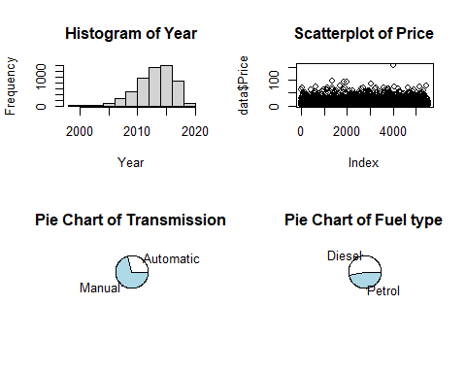
summary(data$Year)
## Min. 1st Qu. Median Mean 3rd Qu. Max.
## 1998 2012 2014 2014 2016 2019
summary(data$Price)
## Min. 1st Qu. Median Mean 3rd Qu. Max.
## 0.450 3.550 5.750 9.405 10.000 160.000
table(data$Fuel_Type, data$Transmission)
##
## Automatic Manual
## Diesel 1058 1913
## Petrol 559 2002
From executing this cell, I can see that from the histogram, the data has the most records around the year 2015. The price of cars are quite low, as the scatterplot shows that throughout the data the vast majority of dots are between 0 and 50, which means 0 and 5000000 INR Lakh, and through doing the summary function on Price, I found that the mean value is 940500 INR Lakh. Through using pie charts, I found that the majority of the Transmission column is Manual cars, and the Fuel type of the data is almost a half and half split. After using the summary function on the year column, I found the maximum value is 2019 and minimum is 1998, this shows there is some outliers as the first quantile is 2012 which is closer to the maximum value (7) than the minimum value(14).
c. Discuss potential research questions that can be analysed using this data, what the main response variable is in the data set. Is there anything to note about this response variable.
From analysing the dataset, I found the response variable is Price. This leads to some possible research questions to be, How does Price vary with the factors: Fuel type, Transmission, Owner type? Is there a relationship between the Kilometres driven and Price? Is there a relationship with Engine size, Power and Price? How does the Year of car affect the Price? The main things to notes about the response variable is the outliers, for extremely cheap and expensive cars, and the context of the price, as certain brands, features and condition can be impacting factors on the Price.
d. Construct an appropriate model to predict the response variable from part c. Make sure the assumptions are met and if they are not met can you make any adjustments to modelling approach to satisfy the assumptions. Once you are happy with the modelling assumptions being met interpret your model.
original_model <- lm(Price ~ Kilometers_Driven + Fuel_Type + Transmission + Owner_Type + Engine + Power + Seats + Year, data = data)
summary(original_model)
##
## Call:
## lm(formula = Price ~ Kilometers_Driven + Fuel_Type + Transmission +
## Owner_Type + Engine + Power + Seats + Year, data = data)
##
## Residuals:
## Min 1Q Median 3Q Max
## -44.096 -2.790 -0.562 1.801 124.622
##
## Coefficients:
## Estimate Std. Error t value Pr(>|t|)
## (Intercept) -2.012e+03 5.991e+01 -33.592 < 2e-16 ***
## Kilometers_Driven 1.661e-06 8.816e-07 1.884 0.05956 .
## Fuel_TypePetrol -2.000e+00 1.871e-01 -10.685 < 2e-16 ***
## TransmissionManual -3.190e+00 2.434e-01 -13.107 < 2e-16 ***
## Owner_TypeSecond -3.667e-01 2.373e-01 -1.545 0.12233
## Owner_TypeThird & Above 6.235e-01 6.453e-01 0.966 0.33397
## Engine 8.712e-04 3.997e-04 2.179 0.02934 *
## Power 1.265e-01 4.175e-03 30.308 < 2e-16 ***
## Seats -4.523e-01 1.642e-01 -2.754 0.00591 **
## Year 9.991e-01 2.976e-02 33.567 < 2e-16 ***
## ---
## Signif. codes: 0 '***' 0.001 '**' 0.01 '*' 0.05 '.' 0.1 ' ' 1
##
## Residual standard error: 6.042 on 5522 degrees of freedom
## Multiple R-squared: 0.6795, Adjusted R-squared: 0.679
## F-statistic: 1301 on 9 and 5522 DF, p-value: < 2.2e-16
par(mfrow=c(2,2))
plot(original_model)
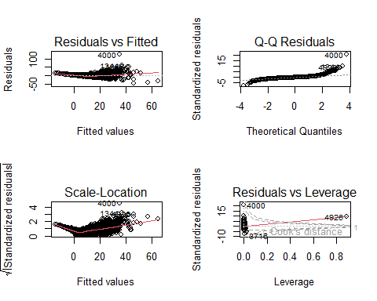
From this code block, I find that there is not much of a relationship between all of the affecting factors and Price, as the r squared value of 0.6795 shows the lack of linearity in this selected data. It is also proven through the residuals vs fitted plot and scale location model as the dots do not match the expected line, this shows there is not much homoscedasticity. Also shown in the Q-Q residuals plot the line does not fit the model well, as it tails off at the start and end of the expected line. The residuals vs levereage plot also is not expected as the majority of dots are at the side closest 0 and off the dashed line. The Cook’s distance model also does not fit the model either as it shows that the model has a very large influence. Overall, this proves that this model is not good at predicting the Price variable with these factors.
e. Are you happy with the fit of the model from part d? Is there anything you would change? Justify your answer.
After reviewing the previous code block, I found this model to be not very good, as the relationship between the Price and the other numerical and categorical factors proved to be not very accurate. The graphs generated from the model are also not very good, as they do not meet the expected fittedness of the different graphs generated. I would remove the factors that have very little influence on predicting the Price. I would remove the Kilometers_Driven variable as it shows little impact on the model.
f. Make the adjustments specified in e and fit this new model. Are the assumptions met? If the assumptions are met, interpret the results for the regression.
library(car)
## Warning: package 'car' was built under R version 4.3.2
## Loading required package: carData
## Warning: package 'carData' was built under R version 4.3.2
new_model <- lm(log(Price) ~ log(Kilometers_Driven) + Fuel_Type + Transmission + Power + Year, data = data)
summary(new_model)
##
## Call:
## lm(formula = log(Price) ~ log(Kilometers_Driven) + Fuel_Type +
## Transmission + Power + Year, data = data)
##
## Residuals:
## Min 1Q Median 3Q Max
## -4.1958 -0.1783 0.0072 0.1884 1.5088
##
## Coefficients:
## Estimate Std. Error t value Pr(>|t|)
## (Intercept) -2.394e+02 3.268e+00 -73.257 < 2e-16 ***
## log(Kilometers_Driven) -3.539e-02 7.230e-03 -4.894 1.02e-06 ***
## Fuel_TypePetrol -2.993e-01 9.463e-03 -31.631 < 2e-16 ***
## TransmissionManual -2.951e-01 1.217e-02 -24.247 < 2e-16 ***
## Power 1.017e-02 1.146e-04 88.733 < 2e-16 ***
## Year 1.196e-01 1.601e-03 74.735 < 2e-16 ***
## ---
## Signif. codes: 0 '***' 0.001 '**' 0.01 '*' 0.05 '.' 0.1 ' ' 1
##
## Residual standard error: 0.3073 on 5526 degrees of freedom
## Multiple R-squared: 0.8677, Adjusted R-squared: 0.8676
## F-statistic: 7247 on 5 and 5526 DF, p-value: < 2.2e-16
vif(new_model)
## log(Kilometers_Driven) Fuel_Type Transmission
## 1.547089 1.303975 1.793887
## Power Year
## 1.935654 1.466422
par(mfrow=c(2,2))
plot(new_model)
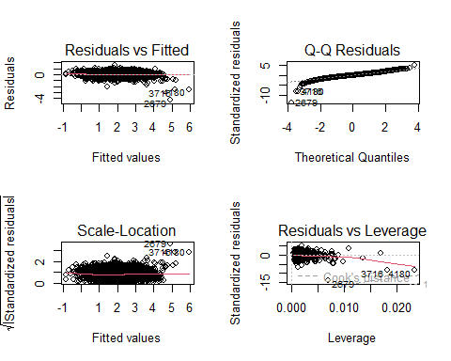
This model is a lot better, the changes that I have made have made the model more useful. The factors that I have included in this model are all of the highest significance so they should be left in. I have also used the log of Price and Kilometres Driven as it makes the model improve linearity, and it makes the variance more even. The plots are a lot better as they match the expected output of each graph. The VIF values indicate that there is moderate correlation with other predictors.
g. Can the models run in part d and f be compared? If so compare and Conclude which model is preferred.
cat('Adjusted R-squared for new_model:',summary(new_model)$adj.r.squared,'\n')
## Adjusted R-squared for new_model: 0.8675592
cat('Adjusted R-squared for original_model:',summary(original_model)$adj.r.squared,'\n')
## Adjusted R-squared for original_model: 0.6789677
cat('AIC for new_model:',AIC(new_model),'\n')
## AIC for new_model: 2654.128
cat('AIC for original_model:',AIC(original_model),'\n')
## AIC for original_model: 35611.91
cat('BIC for new_model:',BIC(new_model),'\n')
## BIC for new_model: 2700.456
cat('BIC for original_model:',BIC(original_model),'\n')
## BIC for original_model: 35684.72
par(mfrow=c(2, 2))
plot(new_model)

plot(original_model)

From executing this code block, I found that the new model’s adjusted R squared value of 0.865592 is higher than the original models’ value of 0.6789677 showing that the new model explains the response variable’s variability better than the original model. The AIC value for the new model is 2654.128 compared to 35611.91 from the original model, this means that the new model is a far better fit for the data. The BIC value of 2700.456 for the new model indicates that it is a better fit than the 35684.72 value of the original model, as it is considerably lower.

